MODELING METHOD FOR DETERMINING COMPLEX PERMITTIVITY AND COMPLEX PERMEABILITY
Ho Manh Cuong^{1,*}, Vu Van Yem²
Abstract: We propose a modeling method for determining the complex permittivity and complex permeability of material samples placed in a free space. The reflection and transmission coefficients (S₁₁ and S₂₁) of planar material samples are determined using the proposed model. The complex permittivity and complex permeability are calculated from the values of S₁₁ and S₂₁. The proposed model is tested with different materials in the frequency range of 8.0 – 12.0 GHz. The results show that the more dielectric loss tangent, the more accuracy of complex permittivity. However, the complex permeability is slightly effected by the magnetic loss tangent.
Keywords: Complex permittivity, Complex permeability, Dielectric loss tangent, Magnetic loss tangent, Electromagnetic.
1. INTRODUCTION
The methods for determining the parameters of material using electromagnetic wave propagation in free space are nondestructive and contactless; hence, they are especially suitable for measurement of the complex permittivity () and complex permeability () of materials under high temperature conditions. In the past, the methods have been used by several investigators for the measurement of electrical properties of materials [1-3]. After then, the methods were developed for determining the complex permittivity and complex permeability of nonmagnetic materials [4-10] at microwave frequencies using reflected and transmitted fields. Authors in [4] present an extension of the methods for simultaneous measurement of and of magnetic materials at microwave frequencies using reflected fields from metal-backed samples. Recently, many methods for determining the parameters of materials have been proposed such as: parallel plane capacitor method, waveguide methods, resonator/oscillator methods, transmission line technique [11-14]. However, the most popular methods for determining the parameter of materials are methods in free space [15-22] due to their advantages such as: (1) No tolerance requirement for positioning the samples as in the waveguide methods which can become crucial at high frequencies. (2) More suitable for arbitrary samples and new composites characterization, since other methods often require speciﬁc sample preparation test and only some special cases can produce necessary results. Nevertheless, in the previous research work, data were collected in the practical experiments with many difficulties such as: collected data are easily effected by environments, limitation of number of material to test, many real-life applications do not need the accuracy of the material’s parameters from the practical experiments.

2. THEORY
Figure 1 shows a planar sample of thickness d placed in free space. The complex permittivity and the complex permeability, relative to free space, are defined as

3. MODELING DETERMINING THE PARAMETERS OF MATERIAL
In order to make the modeling diagram (Figure 2) presented, in this part, we have modeled as follows. We use the Computer Simulation Technology (CST) software to determine scattering matrix S as shown in figure 3:
Figure 3. Modeling determining the parameters of material sample by CST.
In figure 3, two same pyramidal antennas are designed to operate well in the frequency range of 8.0 – 12.0 GHz. The gain and voltage standing wave ratio of the pyramidal horn antennas are 20 dBi and 1.15 at center frequency.
The selected material samples have parameters as follows: The width and length are similar in size of 150mm, thickness of 3mm. The complex permittivity of material samples: , , and ; the complex permeability of material samples: , , and .
4. SIMULATION RESULTS AND DISCUSSION
The reflection and transmission coefficients (S₁₁ and S₂₁) of planar material samples are determined using the proposed model in section 3.2. The calculated from the values of S11 and S21 by equation (14) and (15) in section 2 are determined the complex permittivity and complex permeability.

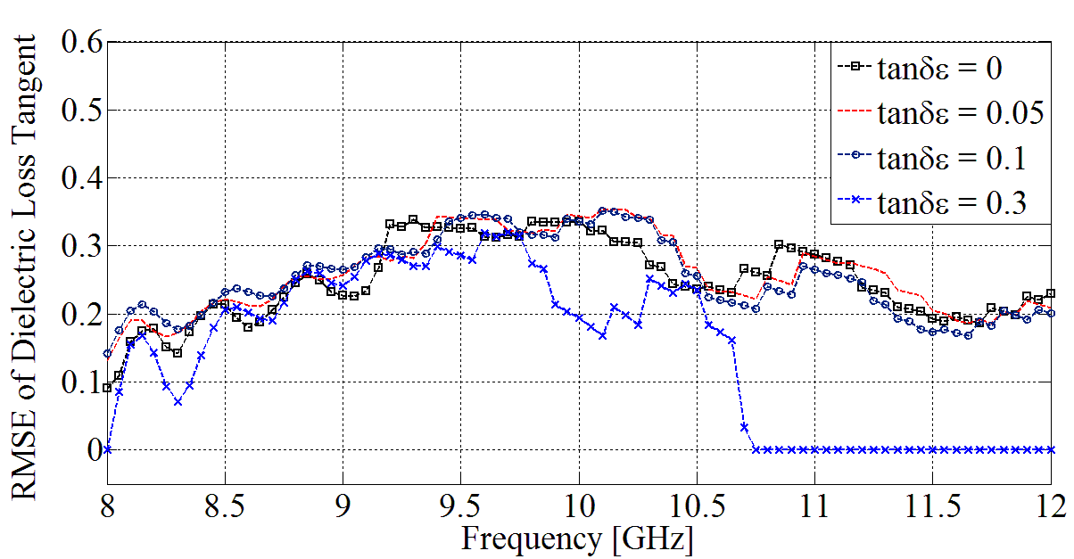
Figure 6. The root mean squared error of dielectric loss tangent the materials.
Figure 6 shows for materials with dielectric loss tangent less than or equal to 0.1. The root mean squared error (RMSE) changes from 0.1 to 0.365. When dielectric loss tangent more than 0.1, the RMSE changes from 0 to 0.315 in the frequency band from 8.0 to 10.7 GHz and equal to 0 in the of frequency band from 10.7 to 12.0 GHz. So, the results show that the more dielectric loss tangent, the more accuracy of complex permittivity.
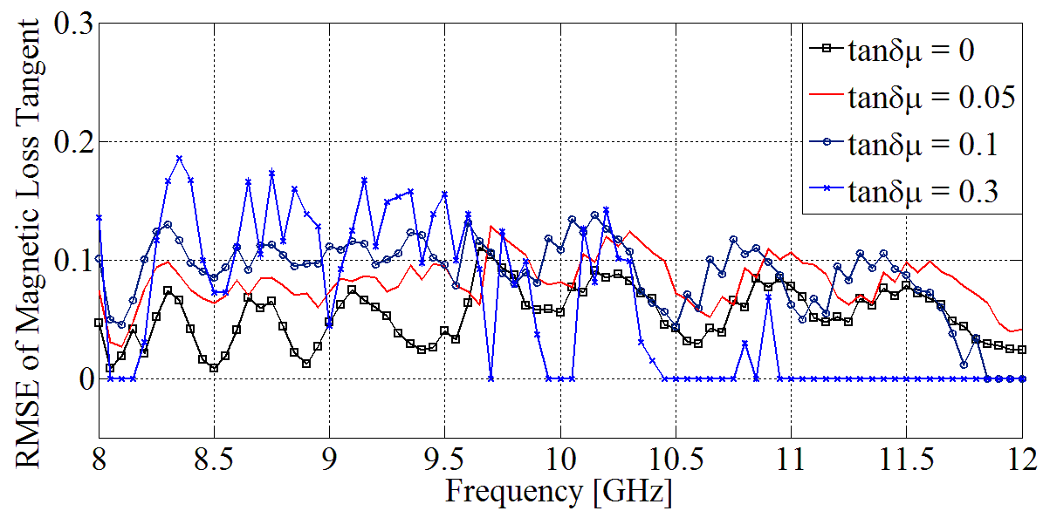
Figure 7. The root mean squared error of magnetic loss tangent the materials.
Figure 7 shows for materials with magnetic loss tangent less than or equal to 0.1. The RMSE changes from 0 to 0.13. When magnetic loss tangent equal to 0.3, the RMSE changes from 0 to 0.185 in the frequency band from 8.0 to 10.9 GHz and equal to 0 in the of frequency band [10.9 GHz - 12.0 GHz]. So, the complex permeability is slightly effected by the magnetic loss tangent.
Results of S₁₁ and S₂₁ parameters were calculated with adaptive mesh refinement. The errors of the imaginary part of complex permittivity and complex permeability only depend on the effect of two antennas. However, this errors are small and acceptable for low-loss materials.

5. CONCLUSION
We propose a modeling method for determining the parameters of materials using electromagnetic wave propagation in free space. The model consists of two antennas placed in a free space and material sample placed in the between focus of the two antennas. The propose model has many benefits for learning and doing research such as time- and cost-saving. In addition, it is also a tool to test the properties of the material in different frequency bands. The results show that for materials with dielectric loss tangent more than 0.1, the more accuracy of complex permittivity.
The methods in free space are application in many scientific fields such as: electronics, communications, metrology, mining, surveying, radar, construction.

ACKNOWLEDGEMENT (OPTIONAL)
REFERENCES
- A. L. Cullen, "A new free-wave method for ferrite measurements at millimeter wavelengths," Radio Science, Vol. 22, pp. 1168-1170, (1987).
- A. M. Nicolson and G. F. Ross, "Measurement of the Intrinsic Properties of Materials by Time-Domain Techniques," IEEE Transactions on Instrumentation and Measurement, Vol. 19, pp. 377-382, (1970).
- W. B. Weir, "Automatic measurement of complex dielectric constant and permeability at microwave frequencies," Proceedings of the IEEE, Vol. 62, pp. 33-36, (1974).
- D. K. Ghodgaonkar. V. V. Varadan, and V. K. Varadan. "A free-space method for measurement of dielectric constants and loss tangents at microwave frequencies," IEEE Transactions on Instrumentation and Measurement, Vol. 38, pp. 789-793, (1989).
- J. Baker-Jarvis, R. Geyer, and P. Domich, "Improvements in transmission line permittivity and permeability measurements," in Precision Electromagnetic Measurements, CPEM '90 Digest, Conference on, pp. 232-233, (1990).
- S. Makino, T.-W. Lee, and H. Sawada, “Blind speech separation,” Dordrecht, the Netherlands: Springer, (2007).
- R. Astudillo, “Integration of short-time fourier domain speech enhancement and observation uncertainty techniques for robust automatic speech recognition,” Ph.D. dissertation, TU Berlin, (2010).

TÓM TẮT
MÔ HÌNH HÓA PHƯƠNG PHÁP XÁC ĐỊNH ĐIỆN MÔI PHỨC VÀ TỪ THẨM PHỨC CỦA VẬT LIỆU SỬ DỤNG TRUYỀN SÓNG ĐIỆN TỪ TRONG
KHÔNG GIAN TỰ DO Ở BĂNG TẦN X

Chúng tôi đề xuất mô hình hóa phương pháp để xác định điện môi phức và từ thẩm phức của các mẫu vật liệu đặt trong không gian tự do. Mô hình hóa được sử dụng để xác định hệ số phản xạ và hệ số truyền sóng (S₁₁ và S₂₁) của các mẫu vật liệu. Điện môi phức và từ thẩm phức được tính toán từ các giá trị S₁₁ và S₂₁. Mô hình đề xuất được kiểm thử với các mẫu khác nhau trong dải tần số 8.0 – 12.0 GHz. Kết quả chỉ ra, đối với vật liệu có tổn hao điện môi lớn thì điện môi phức có độ chính xác hơn. Tuy nhiên, độ chính xác của từ thẩm phức ảnh hưởng không đáng kể bởi tổn hao từ thẩm.
Từ khóa: Điện môi phức, Từ thẩm phức, Tổn hao điện môi, Tổn hao từ thẩm, Sóng điện từ.

Received date, 15th March, 2022
Revised manuscript, 25th April, 2022
Published, 09th May, 2022

Author affiliations:
¹ Electric Power University;
² Hanoi University of Science and Technology;
*Corresponding author: cuonghm@epu.edu.vn

